Xamarin ios push notification

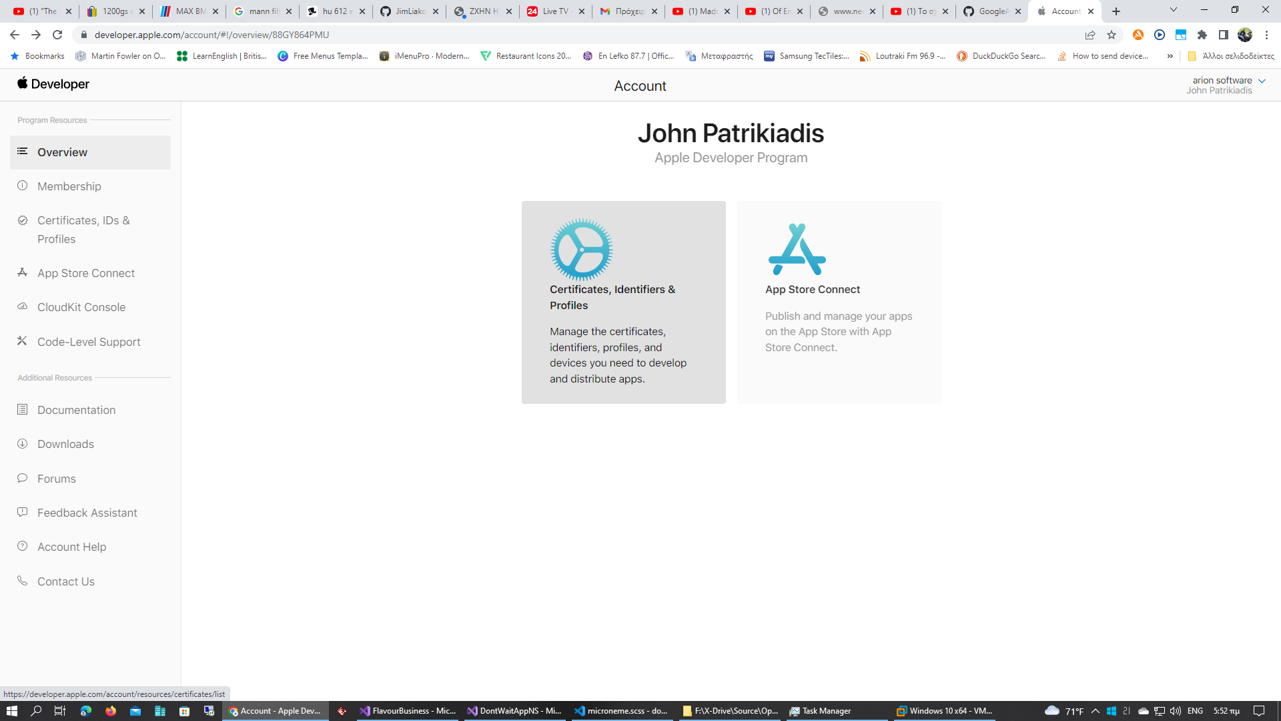

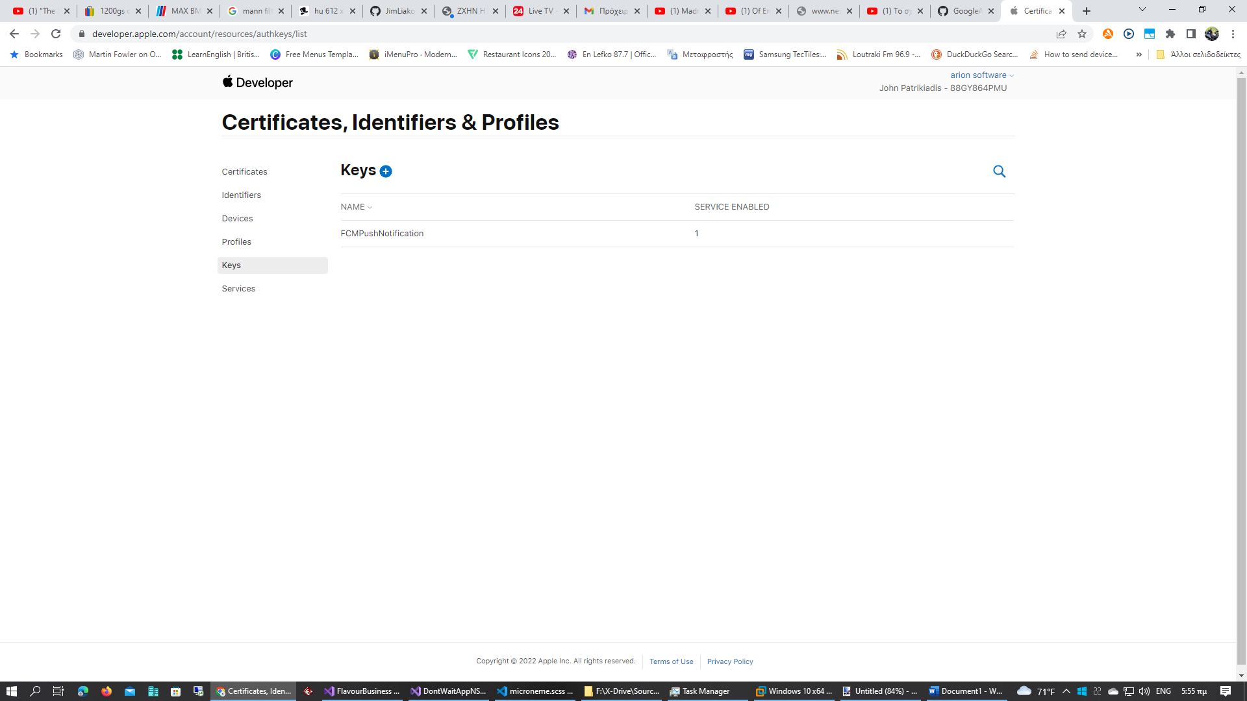

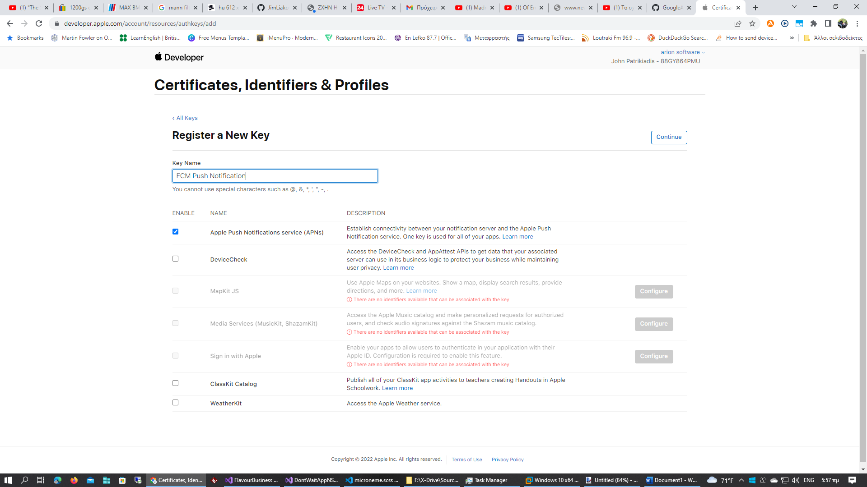

Type Key Name and check Apple Push Notification Service (APNs) .

Click on Continue

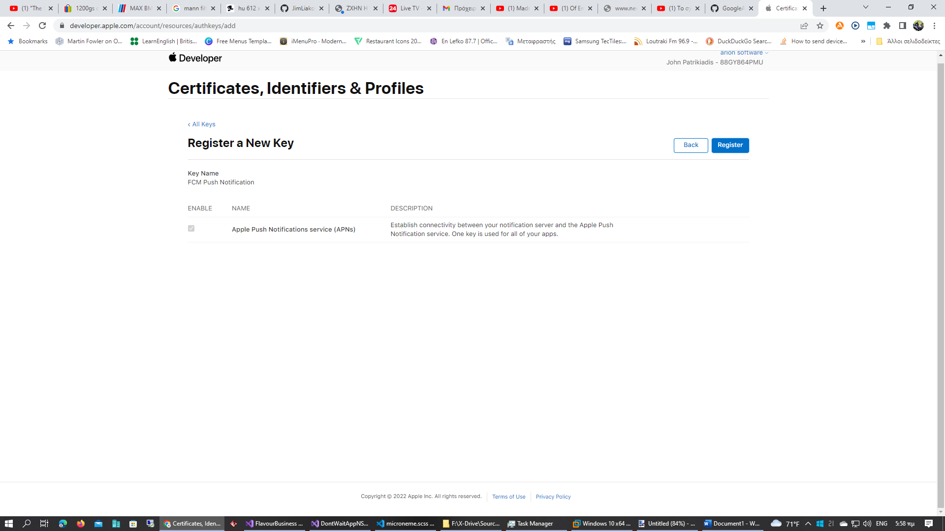

Click on Register

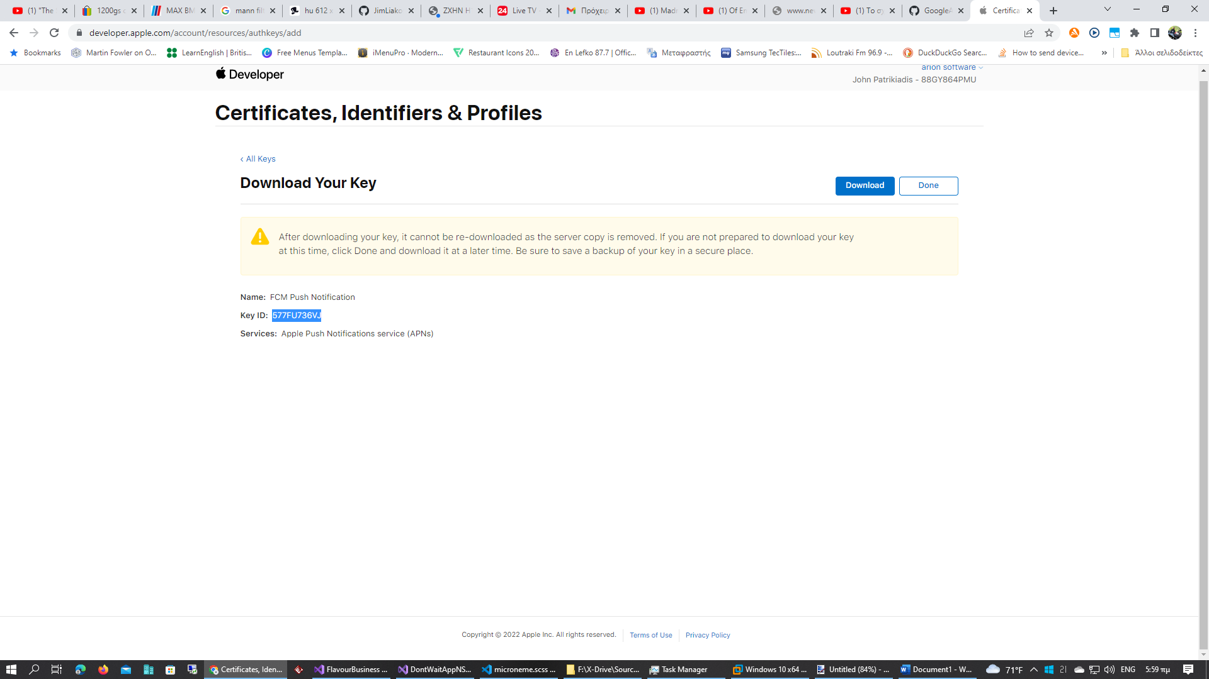

Download Auth key file and copy Key ID

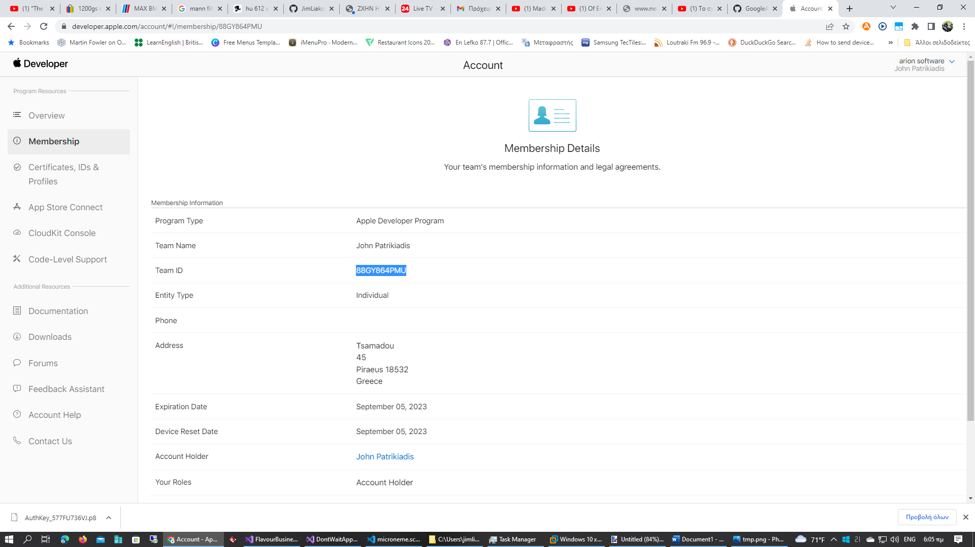

Copy Team ID.

Go to Firebase project settings

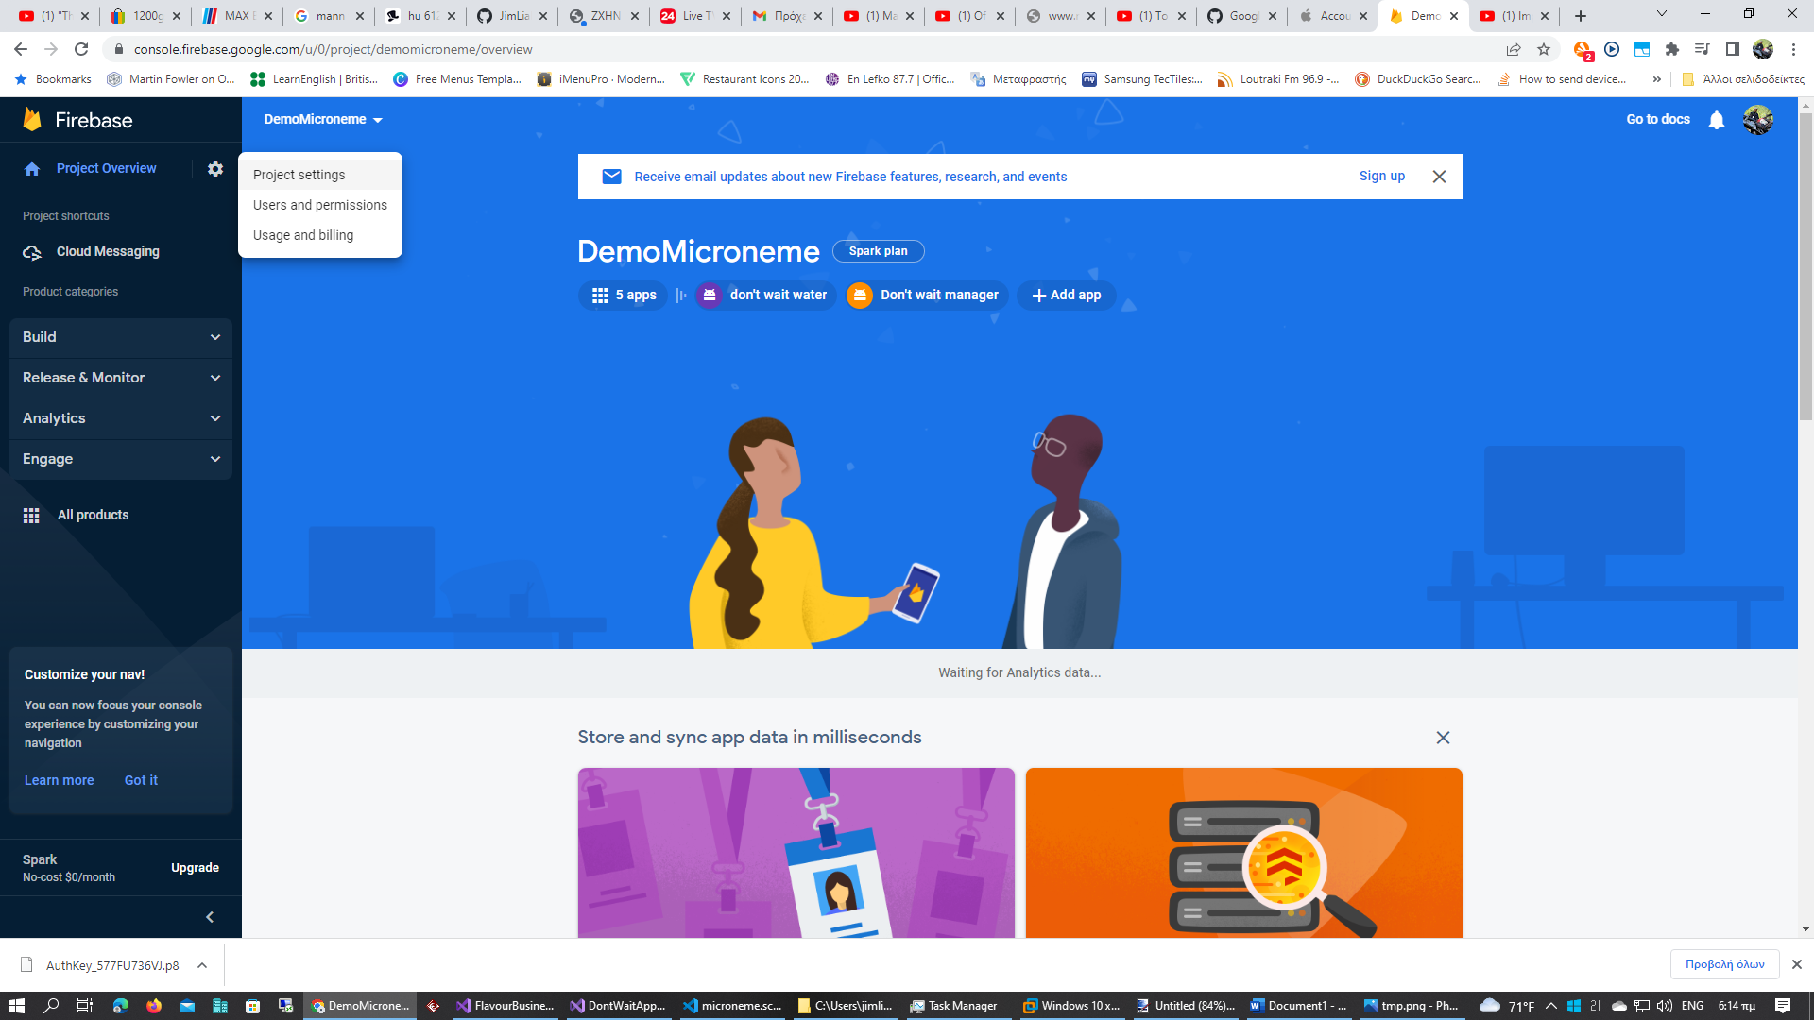

Go to cloud messaging

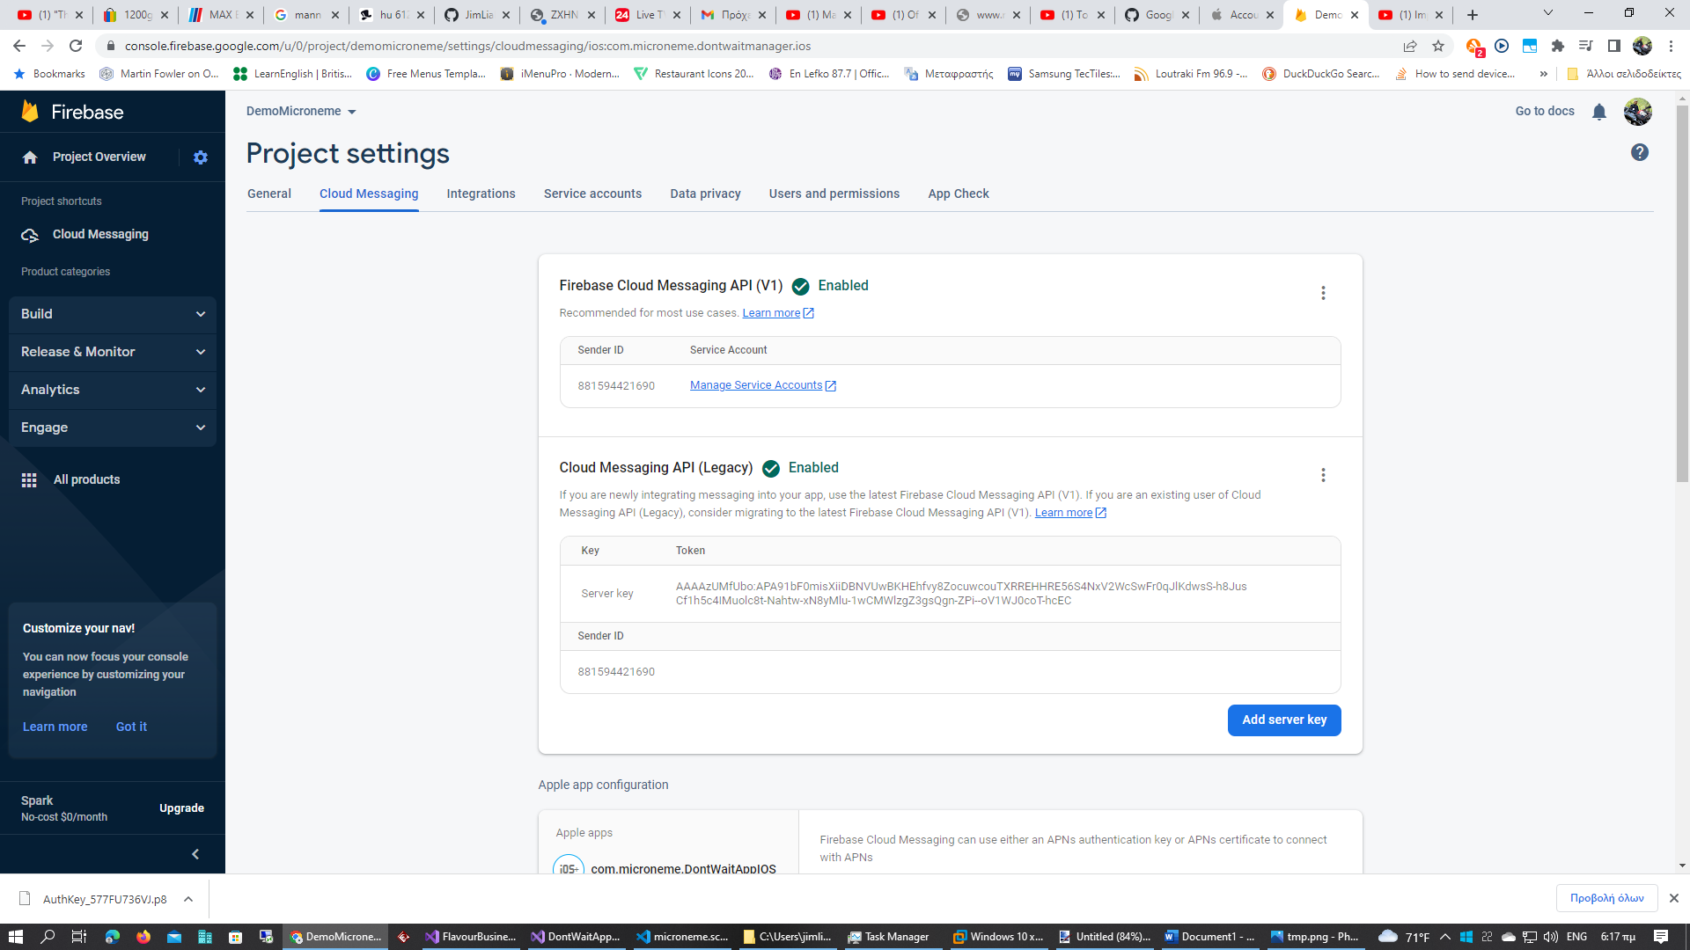

Go to apple app configuration tab select application got to APNs Authentication Key and click upload

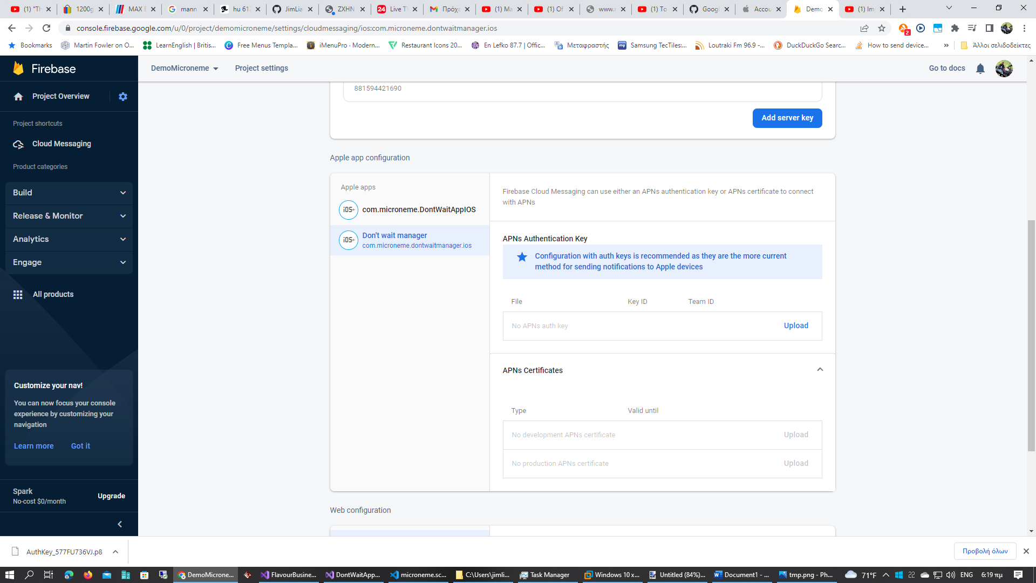

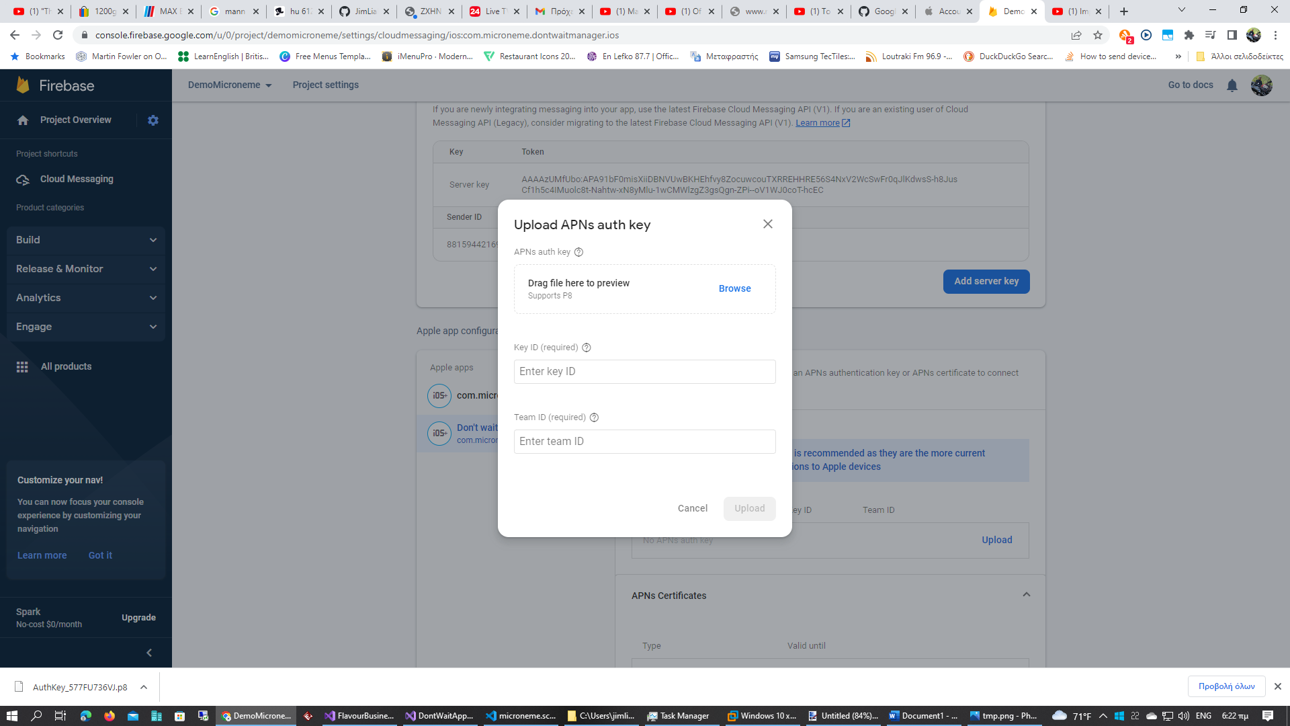

Browse to upload file and paste Key ID and Team ID.

Set up Xamarin.ios app in visual studio to accept push notification message.

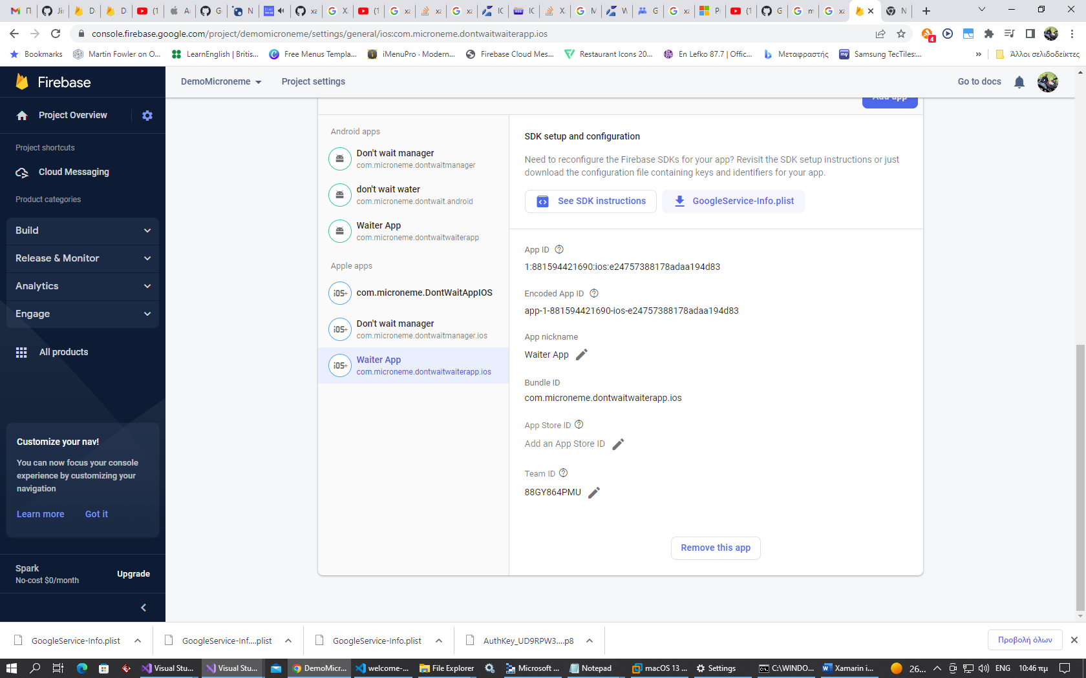

Download GoogleService-Info.plist

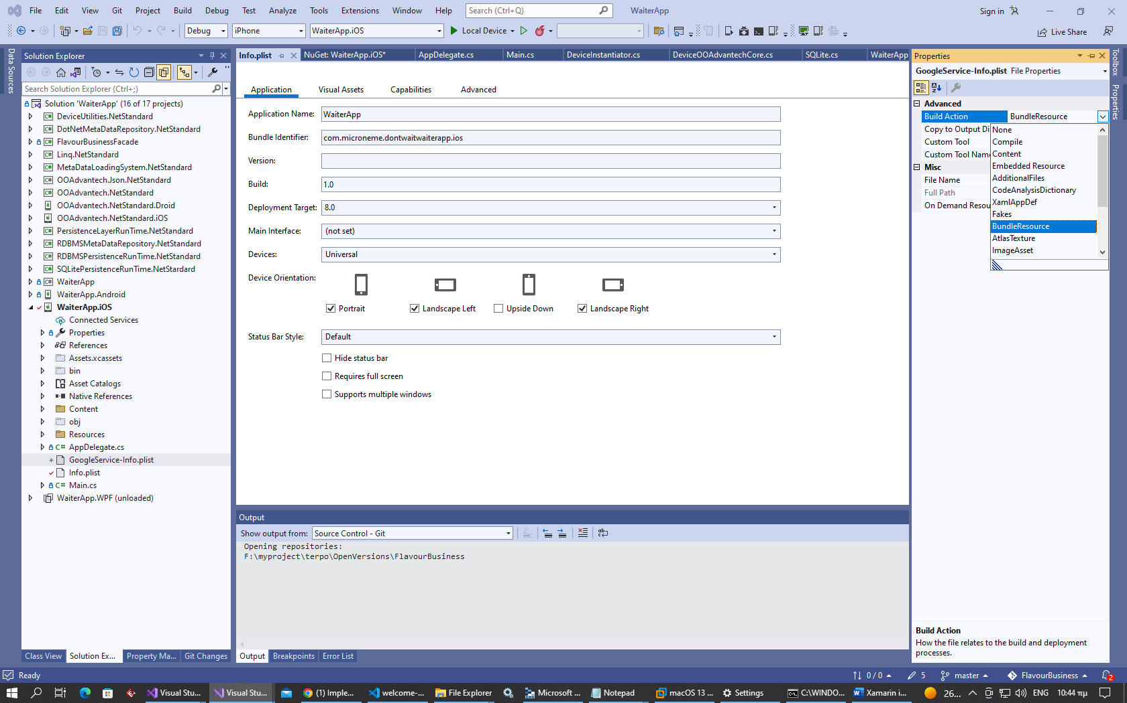

Include GoogleService-Info.plist to project and set build action to “BundleResource”.

Double click on info.plist go to capabilities go to background modes and check Enable background modes and then check remote notification check

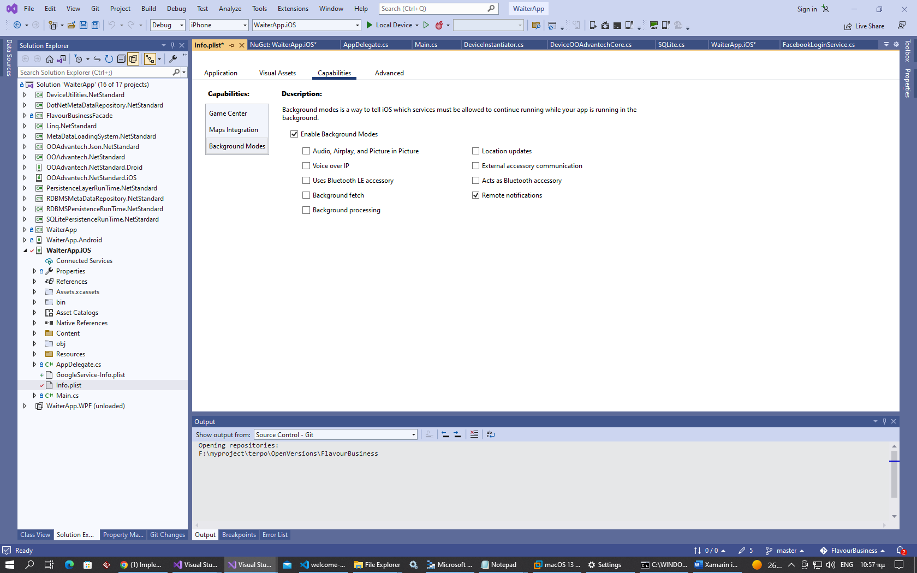

Open info.plist with generic PList editor an add custom property with name FirebaseAppDelegateProxyEnabled and value No .

